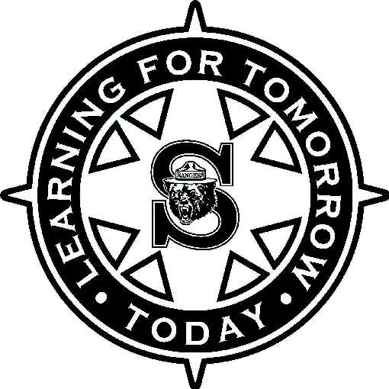

Munn Elementary School
2023 - 2024 Building Plan
Membership:
- Canny, Michael – principal
- Carella, Marie – faculty – year 3 of 3
- Hoadley, Dawn – faculty – year 3 of 3
- Lonardo, Stacy – STA rep
- Lupinetti, Meghan – faculty – year 2 of 3
- Pacitto, Jeanne – faculty – year 3 of 3
- Purtell, Christine – faculty – year 3 of 3
- Quinn, Marisa – parent rep
- Rachel Baldwin– support staff

Munn Building Plan for the 2023 - 2024 School Year

The following goals have been established in alignment with and will support the ongoing strategic planning process. The achievement of these goals will be supported by the action steps found within the Strategic Plan.

2023 – 2024 Strategic Focus
A Connected and Collaborative Environment:

Goal: Munn Elementary School will purposefully stride to meet the relational needs of our school community.
The Student Experience:

Goal: Munn Elementary School will implement an MTSS system that encompasses all relevant learning areas (instruction and SEL/behavioral components).

Academic Excellence:

Goal: Munn Elementary School will build a collective understanding of what cognitive engagement looks like and work to define it developmentally at the elementary level.

Munn Building Plan for the 2023 - 2024 School Year STRATEGIC GOAL ACTION PLAN

Goal: Munn Elementary School will purposefully stride to meet the relational needs of our school community.

Target(s):
- Assess and identify preferred communication and connection opportunities.
- Eliminate barriers to elevate all stakeholder voices.
Strategic Focus 1: A connected and collaborative environment

Strategies that will be used:
Action step(s) initiated | Person(s) responsible | Who must be kept informed and/or involved? | Timeline | Evidence of accomplishment for action step | Mid/End of Year Evaluations
Implement the PBIS building wide theme of Choose to be Kind to teach and reinforce expectations across all settings. | All staff | All staff | Sept-June | All staff will teach, reinforce and celebrate PBIS Expectations in all categories of the matrix  - Extra emphasis on hallway, cafeteria and bathrooms  PBIS matrix  PBIS lessons  SEL block/Community Circles  Monthly spirit days  Monthly assemblies  Red Ribbon Week  Homecoming Week  CASEL Wheel Bulletin Boards  Munn Star/Ranger Bear  Golden Tray Incentive | PBIS Assemblies  Staff Survey Results  Family Survey Results
All will have an intentional focus on greeting of staff and students | All staff | All staff  All families | Sept-June | Staff arrival responsibilities  - Homeroom Teachers greet your students at the doorway.  - All staff will engage with students as they enter the building.  Staff dismissal responsibilities  - All staff will teach PBIS expectations  - All Staff will engage with students as they leave the building  Monthly staff connections  Meet and Greet
All staff and students will engage in experiences to promote connections, relationships and well-being | All staff | All staff | Sept-June | Staff Survey  Staff- Continue community building and staff morale focus at faculty meetings led BPT  PM game days prior to breaks  MSPA Events  Monthly staff connections  ½ day Theme Days  Clubs  Free Little Library
Each student will build connections with trusted adults. | All staff  PBIS committee | All staff  PBIS committee | Sept – June | Survey of students  Bivona “Bookmark”  All staff push in for Monday SEL Community Circle  Check in, check out  Clusters  Connections with office staff during Munn Star  Lunch bunch

Munn Building Plan for the 2023 - 2024 School Year STRATEGIC GOAL ACTION PLAN

Goal: Munn Elementary School will implement an MTSS system that encompasses all relevant learning areas (instructional and SEL/behavioral interventions).

Target(s):
- Employ a cohesive data tracking system (common across elementary) related to the various components of our MTSS framework.
- Align PBIS matrix and practices to systems and structures related to MTSS.

Strategic Focus 2: The Student Experience

Strategies that will be used:
Action step(s) initiated | Person(s) responsible | Who must be kept informed and/or involved? | Timeline | Evidence of accomplishment for action step | Mid/End of Year Evaluations
Continued use of the SEL block to consistently use community circles, promote mental, social, and emotional health and strategies for all students | All staff  . | All staff | Sept- June | Weekly K-5 electronic communication to families of academic and SEL focus  MTSS Behavioral Data  Behavior and Data Collection Form  Student reflections  Staff reflections  SEL journals
Munn Elementary will provide procedures and protocols to ensure students feel safe and secure across all settings. | All staff  . | All staff | Sept- June | SEL Lessons and Instruction  Bivona Lessons  Panoram survey  Revisiting expectations after breaks  TAST  Safety and Security Team  Emergency Response Drills  District TIG Team
All staff will use positive student recognition process to promote successful behaviors. | All staff | All staff | Sept- June | PBIS Student Data  Munn Star  Golden Lunch Tray  Classroom Strategies-Marble Jars, caught being good tickets, etc.
All staff will use the MTSS process including the Behavior and Data Collection Form to document and support the behavioral and social emotional needs of students. | All staff | All staff | Sept- June | MTSS Process and Data

Munn Building Plan for the 2023 - 2024 School Year STRATEGIC GOAL ACTION PLAN

Goal: Munn Elementary School will build a collective understanding of what cognitive engagement looks like and work to define it developmentally at the elementary level.

Target(s):
- Engage in professional learning and exploration of academic cognitive engagement (student and teacher strategies) through the lens of Diversity, Equity and Inclusion.

Strategic Focus 3: Academic Excellence

Strategies that will be used:
Action step(s) initiated | Person(s) responsible | Who must be kept informed and/or involved? | Timeline | Evidence of accomplishment for action step | Mid/End of Year Evaluations
Collect baseline data relative to academic cognitive engagement. | All staff  . | All staff | Sept- June | Surveys and classroom observations
Coupled faculty meetings to develop common understanding, language and learning strategies relative to cognitive engagement. | All staff  . | All staff | Sept- June | District Faculty Meeting  Building Faculty meeting
Offer learning walks targeting cognitive engagement practices across settings and schools. | All staff  . | All staff | Sept- June | https://forms.office.com/r/ta9RjD5634  Liaison groups sharing what they do well and want to share with others.
All students will engage in enrichment clusters and enrichment experiences through student to student, staff to student, and/or community member to student connection. | All staff | All staff | Sept-June | Administer Interest based student survey  Sharing of student interests to guide classroom instruction  Elicit community volunteers to facilitate student learning experiences  One Book, One School

